09 April 2026
NAME:KHADIJA MUSA | Age: Ad | Sex: F
Clinical Details: PELVIC PAIN

REAL TIME PELVIC ULTRASONOGRAPHY EXAM: REVEALED:

URINARY BLADDER: Distended with urine with normal mucosal thickness. No gross masses or stone seen.

UTERUS: anteverted and empty. Normal in size(49mm) and contour. No evidence of pregnancy or retained product of conception. Myometrial and central endometrial echoes are preserved.

CUL-DE-SAC: There is mild free fluid collection in the pouch of Douglas.

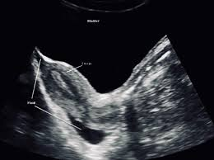
All other abdominal organs were within normal limit.

IMPRESSION: The USS Features are suggestive of PID.

Sonographer
.

